

## Department of Computer Science & Engineering

Rajshahi University of Engineering & Technology

# LAB REPORT

## Topic: Shell Script (Array)

## Course No: CSE 3202

## Course Name: Sessional Based on Operating Systems

Submitted By

Saifur Rahman

Roll No: 1703018

Section: A

CSE, RUET

Submitted To

Mohiuddin Ahmed

Lecturer

CSE, RUET

Date of Lab: 4th Apr 2022

Date of Submission: 16th May 2022

Contents

Program Topic: Find the maximum and minimum number of an array. 1

Program Topic: Sort the elements of an array in ascending and descending order. 2

Discussion: 3

### Program No. 1

### Program Topic: Find the maximum and minimum number of an array.

#### CODE

*#! /bin/bash*

**read** -a arr

**echo** Value of Arrays: ${arr[@]}

max=${arr[0]}

min=${arr[0]}

**for** i **in** ${arr[@]}

**do**

**if** **((** $i **>**= $max **))**

**then**

max=$i

**fi**

**if** **((** $i **<**= $min **))**

**then**

min=$i

**fi**

**done**

**echo** maximum element $max

**echo** minimum element $min

#### OUTPUT

#### 

### Program No. 2

### Program Topic: Sort the elements of an array in ascending and descending order.

#### CODE

*#! /bin/bash*

**read** -a arr

**echo** Values of Arrays: ${arr[@]}

len=${#arr[@]}

**echo** Length: $len

*# bubble sort*

temp=0

*# Ascending*

**for** **((**i=0;i**<**$**((**len-1**))**;i++**))**

**do**

**for** **((**j=0;j**<**$**((**len-i-1**))**;j++**))**

**do**

**if** **((** ${arr[j]} **>** ${arr[$((j+1))]} **))**

**then**

temp=${arr[j]}

arr**[**$j**]**=${arr[$((j+1))]}

arr**[**$**((**j+1**))]**=$temp

**fi**

**done**

**done**

**echo** Array **in** ascending order: ${arr[@]}

*# Descending*

**for** **((**i=0;i**<**$**((**len-1**))**;i++**))**

**do**

**for** **((**j=0;j**<**$**((**len-i-1**))**;j++**))**

**do**

**if** **((** ${arr[j]} **<** ${arr[$((j+1))]} **))**

**then**

temp=${arr[j]}

arr**[**$j**]**=${arr[$((j+1))]}

arr**[**$**((**j+1**))]**=$temp

**fi**

**done**

**done**

**echo** Array **in** descending order: ${arr[@]}

#### OUTPUT

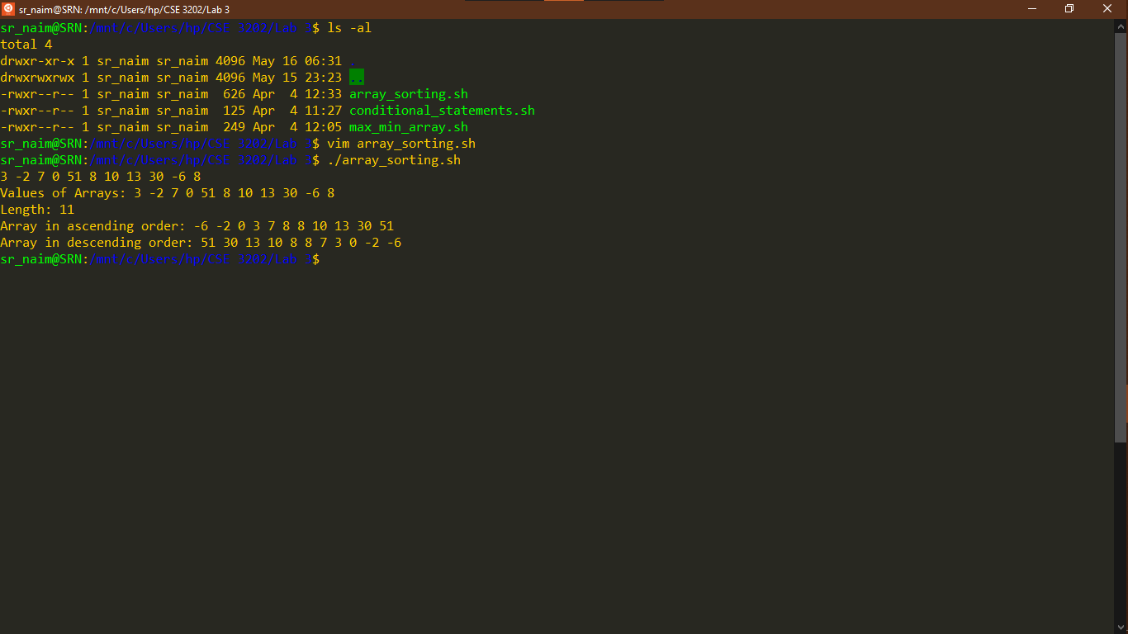

### Discussion:

* In shell scripting, when we access the value of a variable, we use the ‘$’ sign. Otherwise, we do not need to use the dollar sign. For example, while assigning a value to a variable we do not use the dollar sign for the variable we are going to assign on.
* To print all the elements of array an ‘*’ sign can also be used other than ‘@’ sign. We can print all the elements in this way too E.g. ‘${arr[@]:0}’.
* Only the array name without any index specified denotes the first element E.g. ‘${arr}’.
* While using conditional statements or array indexes, we have to be precautious about first brackets and extra spaces. Both could cause an error in the code.